# 

# 

# The Towson University

TIGER

Pep Band

Member Handbook

### Rules, Regulations and Policies

*This handbook and the published schedule serve as the syllabus for the:*

*Pep Band Course - MUSA 270, MUSA 470, & MUSA 659*

2022-2023

Dear TIGER Pep Band Member,

The Towson University TIGER Pep Band performs at all men’s and women’s home basketball games, along with the end of the season tournaments. In addition, we perform at a few other university events during the spring semester.

In this handbook are important details pertaining to membership in the 2022-2023 TIGER Pep Band. Pep band has similarities to our marching band experience, but there are also many differences, therefore, read this information thoroughly. Feel free to contact us at [tubands@towson.edu](mailto:tubands@towson.edu), or through the contact list below with any questions regarding the expectations of pep band membership. We look forward to a great season!

Sincerely,

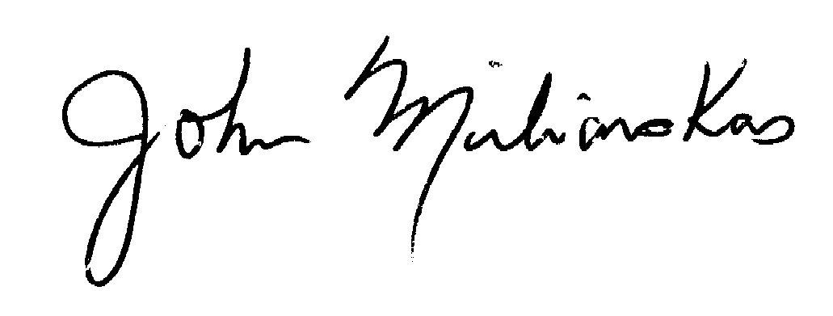

Mr. John Miliauskas

Director of Athletic Bands

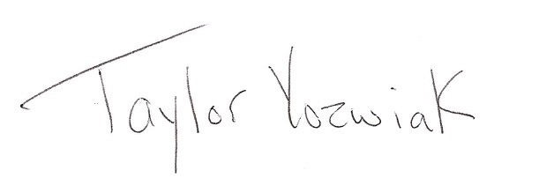

Mr. Taylor Yozwiak

Assistant Director of Athletic Bands

**MEMBERSHIP**

Membership in the pep band is open to registered part- or full-time undergraduate and graduate students of the university. Music and non-music majors are welcome. Students who wish to participate should fill out the interest form and register for the course – MUSA 270, 470, or 659. Students who were members of the marching band during the fall semester have first priority for a position in the pep band. Seniority and instrumentation are also considerations in determining band personnel and stipend availability. Membership is contingent upon the student’s ability to fulfill the requirements of the course as outlined in this handbook.

**CONTACT**

**Email**

[tubands@towson.edu](mailto:tubands@towson.edu)

**Phone**

Mr. Miliauskas, Office Phone – 410.704.5449

Mr. Yozwiak, Office Phone – 410.704.0520

**EMERGENCY/LAST MINUTE CONTACT**

Mr. Miliauskas, Cell Phone - 717.559.3232 – Email, [jmiliauskas@towson.edu](mailto:jmiliauskas@towson.edu)

Mr. Yozwiak, Cell Phone - 443.538.3205 – Email, [tyozwiak@towson.edu](mailto:tyozwiak@towson.edu)

**ONLINE INFORMATION**

Information about the TIGER Pep Band is posted in the following places:

**Official Band Website**:

[www.towsonbands.com](http://www.towsonbands.com)

**Google Members Folder for Pep Band Information:** <https://drive.google.com/drive/folders/1FatCJ3BLHdlQbEmILkxbIU7nJcpoCbJY?usp=sharing>

**TUMB Current Members Facebook Group** (please become a member):

<https://www.facebook.com/groups/tumbcurrentmembers>

**Link to Performance Schedule**:

<https://docs.google.com/spreadsheets/d/1iui20vJYzJdrEDjiSs91eih4jXlUvDSF7M74PRn6miw/edit?usp=sharing>

**Remind App** for last minute changes

## INTEREST FORM

If you are interested in joining the 2022-2023 Pep Band, please fill out the following interest form before **December 2, 2022:**

<https://docs.google.com/forms/d/e/1FAIpQLSeQw6uA2Fvp8Il36dENHsFfgqgDrO1G7JRjbQlZKFGAbY2zmA/viewform?usp=sf_link>

## **ATTENDANCE REQUIREMENTS**

Attendance requirements for the TIGER Pep Band are very different from the attendance requirements of the TU Marching Band. We do not have a regularly scheduled rehearsal time during the spring semester. We will rehearse twice in the fall during the marching band time slot. Prior to all games, we will warm up and have a brief rehearsal 60 - 75 minutes prior to each tip-off. This information is posted on the schedule on the website. Here are the requirements:

1. Rehearsals; Attend (2) rehearsals held during the marching band class time in November or December.
2. Grading:
   * + **10 (or more) On Campus Performances, Plus 1 Tournament** = A
     + **9 On Campus Performances, Plus 1 Tournament =** A-
     + **8 On Campus Performances, Plus 1 Tournament =** B+
     + **7 On Campus Performances, Plus 1 Tournament** = B
     + **6 On Campus Performances, Plus 1 Tournament =** C
     + **5 On Campus Performances, Plus 1 Tournament =** D

**In addition,** a grade can be raised or lowered based on the quality of the individual's performance and overall attitude/effort, following all rules and regulations as outlined in this handbook, and following verbal instructions by the directors.

1. Conference Tournaments

In addition to the On Campus Performances, members are required to *make themselves available* for one of the two end-of-the-season conference basketball tournaments. These tournaments are single elimination meaning that if the team loses, we’re done playing for that tournament. The number of games can range from 1 game if we lose in the opening round, to 3 or 4 games if we make it to the championship game. *The men’s tournament is in Washington DC so we will travel to and from campus each game of the tournament; we don’t stay overnight. The women’s tournament is here on campus in the SECU Arena! Members must clear their calendars for the* ***entire*** *length of the tournaments.*

1. NCAA Tournaments

If either team wins their conference tournament, they would make the NCAA Tournament and we would be expected to attend. Oftentimes, these tournaments are far from campus and involve a rewarding overnight trip! The NCAA limits the number of pep band members for tournament play. Instrumentation, attendance, seniority, marching band membership, game spirit, and “above and beyond” contributions such as SMAC, KKY, or TBS would determine who would get the opportunity to attend an NCAA Tournament.

**SIGNING UP FOR PERFORMANCES & ATTENDANCE RULES**

* At the beginning of the season, performance sign ups will be made available in the Pep Band Folder of the Google Members Folder.
* Sign up in an **orange font** if you’re a “maybe” that you can attend the performance.
* Sign up in **black font** if you definitely can make the performance.
* Put your sign up info in **red font** if you were on the list but no longer can make the performance.
* 24 hours prior to each performance, we will close the roster to changes and consider all names as “definite to attend”. After that point, additions or deletions should go through [tubands@towson.edu](mailto:tubands@towson.edu), or by contacting M or Yoz. This includes illness.
* Absence/No show – All students who are on the final roster are expected to attend. In the rare case of an unexcused absence, or no-show, the student loses their stipend earned from one previous performance. To avoid this, simply communicate with the directors.
* Showing Up to Play Without Signing Up - On a regular basis, to be eligible for the game stipend, you must be on the roster prior to the game. At times, we may need more participants for a game and will put out a “come one, come all” call for the game. In these moments, we may accept members showing up to play without signing up.
* Excessive Tardies - can result in loss of stipend, or reduction of grade. Arriving late for a game can be approved by a director if the student is coming from a class.
* Members are responsible for setup and teardown of any equipment and supplies (i.e. drum set, music stands, music folders, towels). Students should arrive with ample time to accomplish these tasks prior to our time to begin playing.
* Any unusual or extenuating circumstances regarding attendance should be brought to the attention of the directors as soon as possible. See the **Contact Information** at the beginning of the handbook.
* Link to [Roster Sign Ups](https://drive.google.com/drive/folders/1VhfWCypo4revd-EEjPgxJkAugH-HfCQ5?usp=share_link)
* Link to [Performance Schedule](https://docs.google.com/spreadsheets/d/1iui20vJYzJdrEDjiSs91eih4jXlUvDSF7M74PRn6miw/edit?usp=sharing)

**STIPENDS**

All members who sign up for a performance/game will receive class attendance. In addition, members who meet the membership criteria have the opportunity to receive a stipend for each pep band performance. In order to receive the stipend, each band member must remain a “member in good standing” throughout the season. This is defined by the rules, regulations, and policies in this handbook. For some games there will be a limited number of stipends available. Who receives a stipend will be determined by; instrumentation, who signs up first, seniority, marching band membership, January availability, and game conduct. These are all determining factors to receive a stipend. The stipend rewards are placed into student accounts at the END of the spring semester.

**Stipends will be awarded according to the following scale:**

**1st year in pep band** -$20 per performance

**2nd year in pep band** -$25 per performance

**3 or more years in pep band**-$30 per performance

**Out of session games** - $50 for everyone per performance

*Thanksgiving Break and Winter Break. There will be a slightly longer rehearsal prior to these games.*

**More Stipend Information:**

* Students must attend a minimum of **6** performances to be eligible for the stipend program. The 6th performance would enable stipends for the first 5 games. If a student attends just 5 games or less, no stipends will be awarded.
* There may be limited stipend spots for some games. Instrumentation, early sign up, marching band participation, attendance, and general “member in good standing” will determine stipend awards. In these cases, if you didn’t receive a stipend, the game would still count as attendance toward the class requirements.
* For your best opportunity to receive a stipend, make sure to sign up for performances as soon as you know your availability for any given pep band date.
* Pep band stipends are considered financial aid.
* Stipends are deposited into each member’s university account at the end of the season (be patient with the time it takes for this money to arrive in your account). All Band Policies, Attendance, and the Code of Conduct must be followed to receive this money.

***From Financial Aid…***

*If you are a financial aid recipient, receiving a pep band participation scholarship can result in a reduction to another part of your financial aid offer.  Even if you do not apply for financial aid, you should be aware of Towson’s Over-Award Policy for Scholarships. For this and more information on financial aid and scholarships, visit the Financial Aid Office Website at* [*http://onestop.towson.edu/finaid/*](http://onestop.towson.edu/finaid/)

***From Mr. Miliauskas…***

*My understanding is that every student has a maximum amount of financial aid (Scholarships, Stipends, Loans, etc.) that can be received. If the Marching Band or Pep Band Scholarship/Stipend increases that total amount over the limit, a rebate check will not be issued. Instead, the funds will be applied to reduce the amount of a loan or other type of aid.*

**“CORE” PEP BAND WIND PLAYERS!**

New for 2022-23! We will be offering a select number of wind players a one time bonus stipend of $500 on top of the game stipends to commit to performing at ALL performances throughout the winter/spring.

* Auditions are due **December 5th**, begins with the **December 11th** game!
* Individuals will be chosen based on:
  + Instrumentation
  + Ability Through Audition
  + Past Attendance, Past Dedication, & Past Game Spirit as a Member of the Band
  + Marching Band Participation
  + “Above and Beyond” Efforts by Membership in SMAC, KKY, or TBS
  + Member in Good Standing Status
* Students should check their spring classes since there are often Thursday evening games.
* Core Members would need to be available over winter break, and possibly Thanksgiving break if there is a game scheduled.
* Students with a spring internship may not be eligible. Check individually with Mr. Miliauskas or Mr. Yozwiak.
* If a Core Member is sick with Dr’s documentation, or has an extenuating circumstance such as a religious holiday or death in the family, those absences could be considered as excused. We ask you to secure a “sub” for your spot at that performance. In these cases, communicate promptly with the directors.
* If a Core Member has an absence request outside of the above criteria, that request should be submitted at the beginning of the season. This could be a significant event like a sibling who is getting married.
* Core Pep Band Members may need to teach sub-sectional rehearsals prior to games.
* Core Pep Band Members would be expected to be proficient at all the music which could mean outside of band preparation - yes, practicing!

The 2022-2023 Pep Band [Performance Schedule](https://docs.google.com/spreadsheets/d/1iui20vJYzJdrEDjiSs91eih4jXlUvDSF7M74PRn6miw/edit?usp=sharing)

**RHYTHM SECTION**

One of the biggest differences between marching band and pep band is that in pep band we don’t use a battery percussion section. Instead, we utilize a rhythm section of drum set, electric bass, and synthesizer. These positions are very individual and, therefore, very important.

* Members interested in a rhythm section position should attend the pre-season pep band rehearsals where their performance skill sets will be assessed.
* The directors will then request each player’s game availability for the entire season.
* Based on the performance skills demonstrated during the pre-season rehearsals, and their season availability, a schedule of who will perform at which games will be established by the directors. This means there will not be open sign-ups for rhythm section instruments on each game roster.
* If a member of the rhythm section is not assigned to perform at a particular game, there will be limited “stipend” spots available for them to come and just observe.
* ALL members who successfully audition into the rhythm section will receive additional stipend bonus for setup and teardown and are considered a “core” member.

**AUDIO ENGINEER INTERNS**

In addition to our rhythm section electronics, we use 3-4 mics to amplify the entire wind section. To support all our electronics, a team of 2 to 3 audio engineer interns will be selected prior to the Pep Band season. These individuals will be responsible for setting up, operating, and tearing down the Pep Band sound system at each game.

* At the beginning of the season, a schedule of who will provide sound system support at each game will be established.
* Because of the extra time of setup and teardown, members of the audio engineer team will receive a stipend bonus in addition to each game stipend.

**UNIFORM**

Members of the TIGER Pep Band are required to wear the following at every performance:

* The band shirt that is issued to you.
* Khaki pants (tan in color and no jeans).
* Dark dress or casual shoes and dark socks (no sneakers unless they are 99% black).
* If you need to wear another shirt under the band shirt to stay warm, use a black shirt so it is not noticeable.
* No hats are allowed.

*Failure to wear the required dress could result in loss of stipend for the event, and/or the student sent home without participating.*

**INCLEMENT WEATHER**

If there is inclement weather for a game, members should check their email and the TU Marching Band Facebook group pertaining to the status of the game. If the university closes, most likely the basketball game will still take place. If you live on campus or very close by, please make yourself available to perform during inclement weather.

## CODE of **CONDUCT**

* **School Spirit!** Every TIGER Pep Band member should stand with their section throughout the entire game, and be actively involved in cheering on our Tigers! Members of the TIGER Pep Band are receiving a stipend to perform at games and support the TU Basketball teams. This includes playing, cheering, and representing the university in an overall positive manner.
* Rude or inappropriate remarks including profanity are unacceptable. School spirit should be displayed by supporting Towson University, not by heckling the opposition. Individual outbursts or other grandstanding actions are inappropriate. We should set a positive example of TU sportsmanship during the game!
* NCAA rules forbid playing while the clock is running; consequently, there is to be no individual playing of your instruments in the stands. The only time you may play is as an entire group.
* Pep Band members will not engage in the use of alcohol or illegal drugs prior to or during participation in any pep band function. Students found to be in violation of this policy and the concurrent university policies on Alcohol and Substance Abuse are subject to immediate suspension, loss of stipend, a failing grade, and/or dismissal from the pep band.
* There is to be no one other than Pep Band personnel sitting with the band in the stands. Family and friends may sit near us, but not within our ranks.
* Towson University’s Code of Student Conduct should be followed at all times when participating in the Pep Band. This included all on campus, and off campus activities.

<https://www.towson.edu/studentaffairs/policies/documents/code_of_student_conduct.pdf>